Project 5-7: Using a Software Keylogger
Estimated Time: 30 minutes
Objective: Explore the features of a keylogger.
Description: A keylogger program captures everything that a user enters on a computer keyboard. In this project, you download and use a software keylogger.

Caution: The purpose of this activity is to provide information regarding how these programs function in order that adequate defenses can be designed and implemented. These programs should never be used in a malicious fashion against another user.

- Open your web browser and enter the URL refog.com. (If you are no longer able to access the program through the URL, use a search engine to search for “Refog Keylogger.”)
- Click Features to see the features of the product.
- Click Home.
- Click Download.
- Click Create an account and enter the requested information.
- Click Download.
- When the file finishes downloading, run the installation program. Note that you may have to enter the password on the previous page to extract the files.
- When prompted with I’m going to use this software to monitor: select My own computer.
- Click Hide program icon from Windows tray. Click Next.
- Click I Agree.
- Click Select All and then Next.
- Create a login and password for the online dashboard. Click Activate.
- You will receive a message that the subscription has expired. Click Yes to install in offline mode.
- Click Install.
- Click Restart Now.
- After the computer has restarted, use the keystroke combination Ctrl+Alt+Shift+K to launch Refog Keylogger.
- Click Tools and then click Settings.
- Note the default settings regarding what is captured.
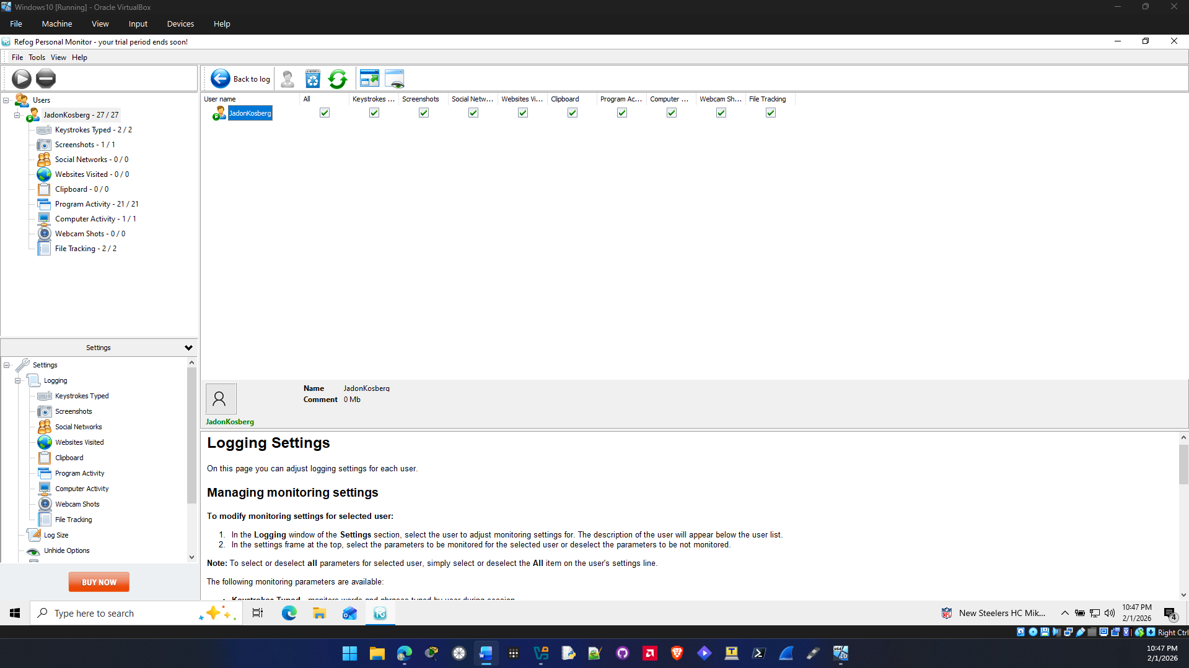

- Click Back to log.
- Minimize Refog Keylogger.
- Use your computer normally by opening a web browser to surf to a website. Open Microsoft Word and type several sentences. Open and close several programs on the computer.
- Maximize Keylogger and note the information that was captured.
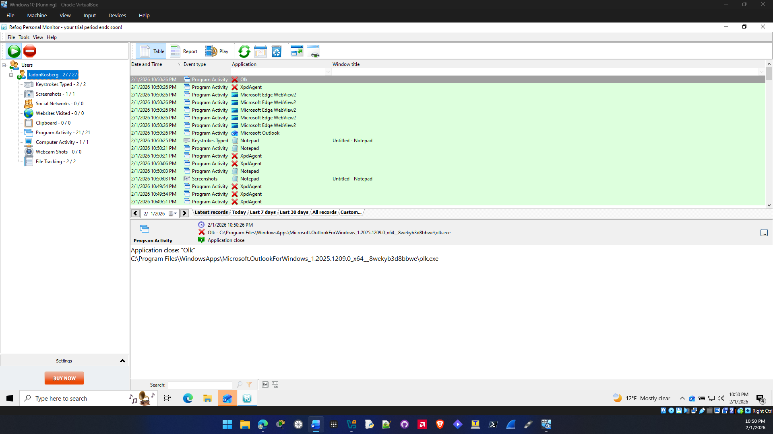

- In the left pane, click through the different items that were captured.
- Under Settings, click Websites Visited.
- Under Websites Visited, click Make website screenshots.
- Click Apply.
- Open a web browser and surf to multiple websites.
- Under Users, click Websites visited. Note the screen captures of the different sites.
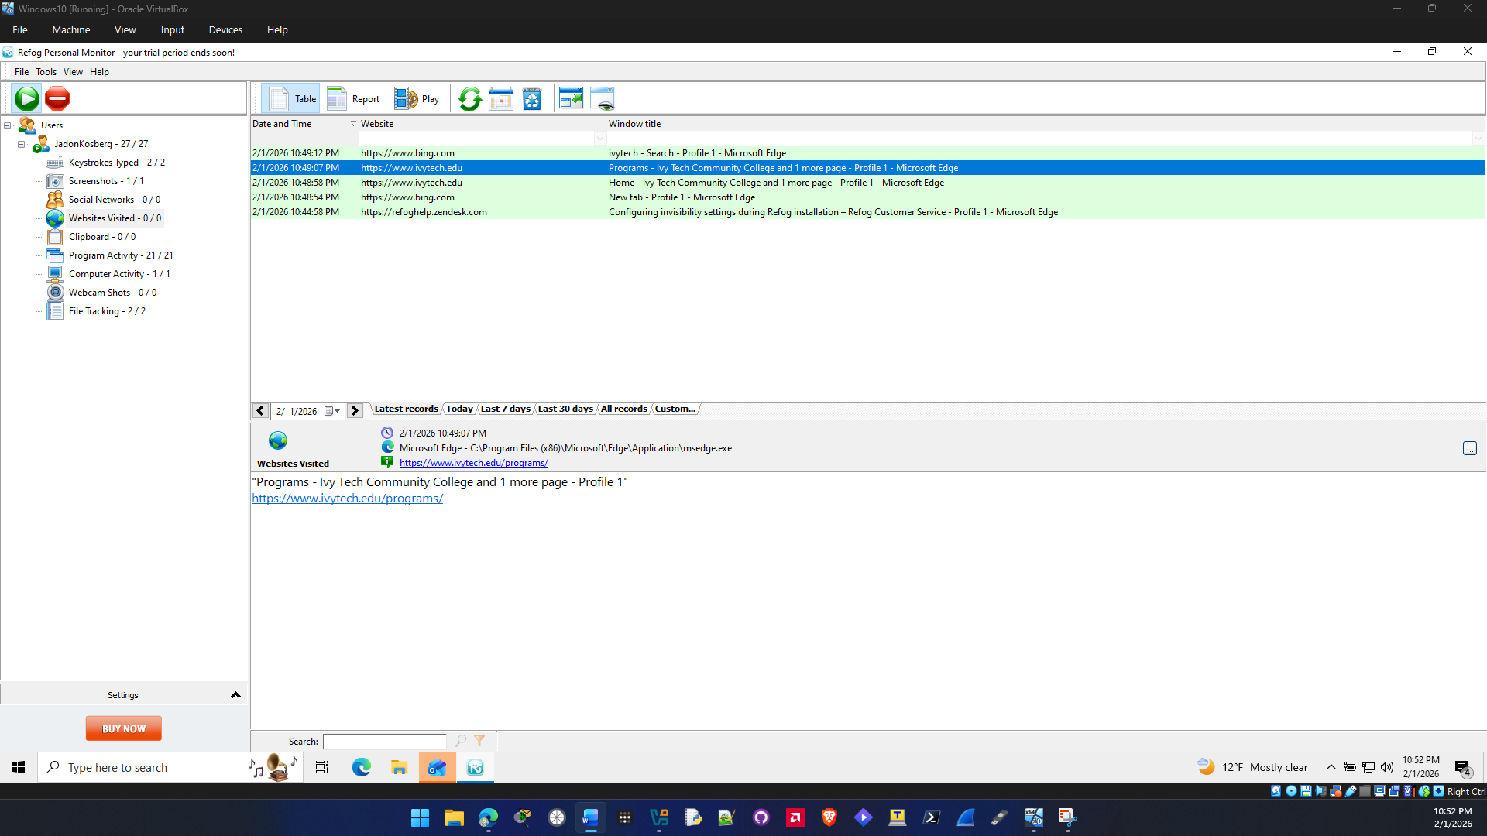
- What type of information would a software keylogger provide to a threat actor? How could it be used against the victim?
A keylogger can provide all kind of information to a threat actor. It can give them people passwords and account information. It can also give other sensitive information like credit card numbers and ssn numbers. This can be used to access peoples account and steal there data and identity. It can also let threat actors get access into your sensitive accounts like bank accounts.

- Click File and then Exit to close Keylogger.
- You may uninstall Keylogger if you wish.
- Close all windows.

Criteria | Meets Requirements | Needs Improvement | Incomplete
Content | The assignment clearly and comprehensively addresses all questions in the assignment.  15 points | The assignment partially addresses some or all questions in the assignment.  8 points | The assignment does not address the questions in the assignment.  0 points
Organization and Clarity | The assignment presents ideas in a clear manner and with strong organizational structure. The assignment includes appropriate content, coverage of facts, arguments, and conclusions.  10 points | The assignment presents ideas in a mostly clear manner and with some organizational structure. The assignment includes appropriate content, coverage of facts, arguments, and conclusions.  7 points | The assignment does not present ideas in a clear manner or with a strong organizational structure. The assignment includes some appropriate content, but coverage of facts, arguments, and conclusions are not logically related and consistent.  0 points
Research | The assignment is based upon appropriate and adequate data collection and analysis of results from the activity or research from academically reliable sources.  5 points | The assignment is based upon adequate data collection and includes some analysis of results from the activity or research from academically reliable sources.  3 points | The assignment is not based upon appropriate data collection and includes no analysis of results from the activity or research from academically reliable sources.  0 points
Grammar and Spelling | The assignment has two or fewer grammatical and spelling errors.  5 points | The assignment has three to five grammatical and spelling errors.  3 points | The assignment has more than five grammatical and spelling errors, is incomplete, or is unintelligible.  0 points

